

**Reviews of Results - Information for candidates**

The following information explains what may happen following a review of results of an examination.

If your examination centre makes a request for a review of marking of your examinations after your subject grade has been issued, there are three possible outcomes:

* Your original mark is confirmed as correct, and there is no change to your grade
* Your original mark is raised, so your final grade may be higher than the original grade you received (eligible for a refund of fees)

• Your original mark is lowered, so your final grade may be lower than the original grade you received

In order to proceed with the review service, you must complete and sign the form below. This tells the Exams Officer, Mrs Leach, that you have understood what the outcome might be, and that you give your consent to the review being made.

**Candidate consent:**

**Centre name: Pinner High School Centre number: 12715**

**Candidate Number: ……………**

**Candidate Name: ………………………………………………………………………**

**Details of review request(s):**

**(Exam board, A Level/GCSE, Subject title, papers/units, Review Service)**

**1.………………………………………………………………………………………………………………..**

**.…………………………………………………………………………………………………………………**

**2.………………………………………………………………………………………………………………..**

**.………………………………………………………………………………………………………………...**

**3. ……………………………………………………………………………………………………………….**

**.………………………………………………………………………………………………………………...**

**Total cost £………………..- charges are per paper** (see fees overleaf)

**I give my consent to the Exams Officer to make a review of the results of the examination(s) listed above. In giving consent I understand that the final subject grade awarded to me may be lower than, higher than, or the same as the grade which was originally awarded for this subject.**

**Signed (candidate): ……………………………………………… Date: …………**

**PLEASE EMAIL THIS COMPLETED FORM TO HLEACH@PINNERHIGHSCHOOL.ORG**

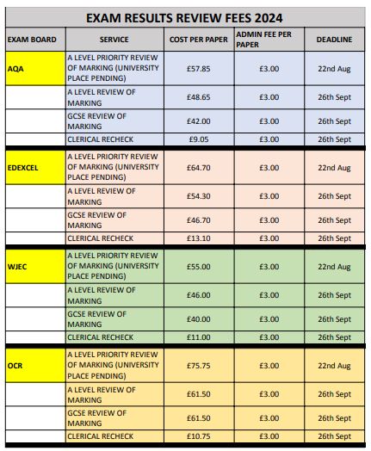

**ACCESS TO SCRIPTS** (ATS) is a further non-chargeable service which you may also request.

For further information please see the relevant document on the JCQ website

https://www.jcq.org.uk/wp-content/uploads/2024/04/Post-Results-Service_24_FINAL.pdf